**Psy 1110 Miniproject #5**

1. Given the following sample data set, answer the following questions below.

1 1 1 1 2 2 2 3 3 5

1A. Complete the grouped frequency distribution.

Real Limits Score (X) Frequency Cum f r% cum%

0.5 – 1.5 1

2

3

4

5

|  |  |  |  |  |  |
| --- | --- | --- | --- | --- | --- |
| Real Limits | Score (X) | Frequency | Cum f | r% | cum% |
| 0.5 - 1.5 | 1 | 4 | 4 | 40% | 40% |
| 1.5 – 2.5 | 2 | 3 | 7 | 30% | 70% |
| 2.5 – 3.5 | 3 | 2 | 9 | 20% | 90% |
| 3.5 – 4.5 | 4 | 0 | 9 | 0% | 90% |
| 4.5 – 5.5 | 5 | 1 | 10 | 10% | 100% |

1B. What score is associated with the 70th percentile?

2

1C. What is the percentage of scores between 1.5 and 3.5?

90%

1D. Is this distribution (circle one)

a) normally distributed

b) negatively skewed

c) positively skewed

C. Positively Skewed

1E. Construct a histogram. Make sure to label

it appropriately.

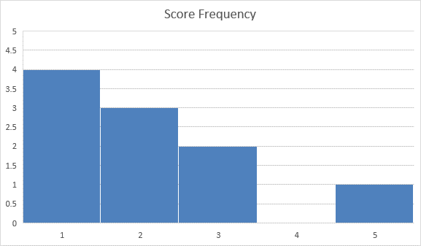

1. Every year, “Nathan’s” hotdog stand of Coney Island, NY holds a hotdog-eating contest.

Assume that the number of hotdogs eaten by the contestants last year was normally

distributed with a mean of 40 and a standard deviation of 5.

**(SHOW ALL WORK!)**

2A. What is the median of this distribution?

Normally Distribution, mean = median, 40

2B. In what percentile would one fall if they ate 36 hotdogs?

Z = (36 – 40) / 5 = -0.8

Using Z-table: 21st Percentile

2C. What percentage of contestants ate between 45 and 50 hotdogs?

Z1 = (45 – 40) / 5 = 1

Z2 = (50 – 40) / 5 = 2

Z1 Lookup = 0.8413

Z2 Lookup = 0.9772

Z2 Lookup – Z1 Lookup = 0.1359

13.59%

2D. How many hotdogs would one have needed to eat to fall at the 33rd percentile?

-0.44 = (X – 40) / 5

(-0.44 * 5) + 40 = X

37.8 Hotdogs => 38 Hotdogs

3. Mrs. Kaye was interested in getting to know her new kindergarten class and she found out that they all like animals. She asked 10 of her 30 students how many times they have been to the petting zoo. The children’s answers appear below. Use this data to answer the following questions:

0 0 1 1 2 3 4 4 4 5

**(Show all Work! Use computational formula)**

(0 + 0 + 1 + 1 + 2 + 3 + 4 + 4 + 4 + 5) / 10

3A. Mean _2.4

3B. Median __2.5

3C. Mode __4

3D. Interquartile Range __1.5

Median of 0 0 1 1 2 => 1

Median of 3 4 4 4 5 => 4

2.5 – 1 = 1.5

4 – 2.5 = 1.5

3E. Variance __3.38

|  |  |  |  |  |
| --- | --- | --- | --- | --- |
| Petting Zoo Visits (X) | (X - Mean) ^ 2 |  | Mean | 2.4 |
| 0 | 5.76 |  |  |  |
| 0 | 5.76 |  | Sum of (X - Mean) ^ 2 | 30.4 |
| 1 | 1.96 |  | Variance (Sum of (X - Mean) ^ 2 / (Sample Size - 1)) | 3.377778 |
| 1 | 1.96 |  |  |  |
| 2 | 0.16 |  |  |  |
| 3 | 0.36 |  |  |  |
| 4 | 2.56 |  |  |  |
| 4 | 2.56 |  |  |  |
| 4 | 2.56 |  |  |  |
| 5 | 6.76 |  |  |  |

3F. Standard Deviation ___1.84

Sqrt(Variance) = Sqrt(3.38) = 1.84